**Planning Proposal**

**Administrative Amendment**

**411 Pacific Highway Belmont North and**

**10, 24 and 28 Bluebell Street Belmont**

**Draft Amendment No. XX to Lake Macquarie Local Environmental Plan (LMLEP) 2014**

|  |  |  |
| --- | --- | --- |
| **Local Government Area:** | | Lake Macquarie City Council (LMCC) |
| **Name of Draft LEP:** | | Lake Macquarie Local Environment Plan (LMLEP) 2014 |
| **Subject Land:** | | Lot 81 DP 536711, 411 Pacific Highway, North Belmont, and Lot 127 DP 861468, 10 Bluebell Street, Lot 1  DP 449422, 24 Bluebell Street and Lot 1 DP739866 28 Bluebell Street, Belmont. |
| **Land Owner:** | | Ian Bower Properties Pty Ltd, Mr D J Cook and Mrs M A Cook and Macquarie Timber & Building Supplies Pty Ltd |
| **Applicant:** | | Lake Macquarie City Council |
| **Folder Number:** | | RZ/1/2016 |
| **Date:** | | 11 August 2016 |
| **Author:** | | Adam Kennedy - Student Landuse Planner |
| **Tables:** | Table No. | Details |
|  | 1 | Assessment of the Planning Proposal against relevant SEPPs |
|  | 2 | Consistency with applicable Section 117(2) Ministerial Directions |

|  |  |  |
| --- | --- | --- |
| **Maps:** | Map No. | Details |
|  | 1 | Locality |
|  | 2 | Aerial Photo |
|  | 3 | Existing Zones Under LMLEP 2014 |
|  | 4 | Existing Uses |
|  | 5 | Proposed Additional Permitted Uses |

**Part 1 – OBJECTIVES OR INTENDED OUTCOMES**

The objective of the Planning Proposal is to amend Lake Macquarie Local Environmental Plan 2014 (LMLEP 2014) in order to permit, with consent, a *vehicle body repair shop,* and *timber yards* within a Zone B7 Business Park. The intended outcome is to enable existing businesses to expand and grow in the localised area.

**Part 2 – EXPLANATION OF PROVISIONS**

The proposed objective will be achieved by amending the LMLEP 2014 by:

|  |  |
| --- | --- |
| **Amendment Applies to** | **Explanation of provision** |
| Addition to Schedule 1 Additional Permitted Uses | Permit a *vehicle body repair workshop* on Lot 81 DP 536711, 411 Pacific Highway Belmont North and Lot 1 DP 739866, 28 Bluebell Street, Belmont |
| Addition to Schedule 1 Additional Permitted Uses | Permit *timber yards* on Lot 1 DP 449422, 24 Bluebell Street and Lot 127 DP 861468, 10 Bluebell Street, Belmont |

**Part 3 – JUSTIFICATION**

**Section A – Need for the Planning Proposal**

1. ***Is the planning proposal a result of any strategic study or report?***

The Planning Proposal is not the result of a strategic study or report. The purpose of the Planning Proposal is to put in place additional permissible uses that reflect the historical uses of the affected lots. During the preparation of LMLEP 2014 the previous zoning 4(2) General Industrial under the LMLEP 2004 was converted to a B7 Business Park zone. The B7 Business Park zone was consistent with the predominant uses occurring in the Business precinct, which included bulky goods, retail, hardware, storage facilities and vehicle repair. However, it also made current land uses of *vehicle body repair workshops* and *timber yards* prohibited. The implications are that affected lot owners can no longer expand business operations. Allowing Schedule 1 Additional Permissible Uses will amend current prohibited uses being undertaken on the affected lots, while signalling towards a lower impact business precinct.

1. ***Is the planning proposal the best means of achieving the objectives or intended outcomes, or is there a better way?***

In order to achieve the intended outcome the following options were considered:

**Option 1 – Continuation of Existing Use**

The Lake Macquarie Local Environmental Plan 1984 (LMLEP1984) applied a 4(2) General Industrial zone to the Belmont North Business Precinct, including the subject lots. Extensive resources were put into establishing appropriate land uses through the preparation of the Lifestyle 2020 Strategy, which ultimately informed the distribution of zones under Lake Macquarie Local Environmental Plan 2004 (LMLEP2004). The standard LMLEP2014 saw a similar decision making process, which determined the Belmont North area better suited as a commercial bulky goods precinct. Therefore, a B7 Business Park was determined as the best suited zone as it provided a wide range of land uses.

Existing use rights potentially may be utilised by the subject lots as uses were permissible under the LEP2004 when the zone was classed 4(2) General Industrial. However, affected business owners argue relying on existing use rights provisions would create a degree of uncertainty and restriction on expansion, and was not of reassurance to the landowners.

**Option 2 – LEP Amendment**

**Zone Options**

**Rezone all subject lots to either IN1 General Industrial or IN2 light Industrial**

Consideration was given to rezone affected lots back to a comparable industrial zoning as in LMLEP2004 such as 4(2) General Industrial. Comparable zones of LMLEP2014 would be IN1 or IN2 zones. This selection of zone would allow for a wider range of industrial uses such as manufacturing, vehicle body repair workshops and timber yards.

However, this was considered to be problematic as the broad range of uses permissible under IN1 and IN2 would suggest the Belmont North Business Precinct was suitable for higher impact industrial uses. The area is in close proximity to an R3 Medium Density Residential zone, so higher impact industrial uses should actually be discouraged. Also, higher impact industrial land uses have greater potential to impact on the E2 Environmental Conservation zoned area to the east of 10 and 24 Bluebell Street (Lot 127 DP 861468, Lot 1 DP 449422).

**Permit additional permissible uses for Industry (General) within 411 Pacific Highway, Belmont North**

Consideration was initially given to permitting, with consent, *industry (general industry)* on 411 Pacific Highway (Lot 8 DP 536711). Currently, a manufacturing business (Vogue Joinery) is located to the rear portion of the property with an access road from Cobbin Parade. The use is prohibited in the B7 zone. Again, the broader range of permissible uses in this zone was deemed unsuitable for this site.

Further, the business (Vogue Joinery), has had a history of land conflict issues with surrounding residents. These land conflict issues have included working outside trading hours, cargo arriving outside of trading hours and noise complaints. It was believed that the inclusion of *industry* *(general industry)* would potentially increase land use conflicts with surrounding residents.

**Rezone split zoning of 10 Bluebell Street to B7 with enabling clause**

Council staff consulted with the property owner of 10 and 24 Bluebell Street (Lot 127 DP 861468; Lot 1 DP 449422) and were advised of ongoing issues of land zoning of 10 Bluebell Street. The lot is partly zoned B7 Business Park and E2 Environmental Conservation.

10 Bluebell Street (Lot 1 DP 449422) was originally zoned 4 (a) General Industrial under Lake Macquarie’s Northumberland Planning Scheme 1960. The land was then split into 4 (a) General Industrial and 6 (c) Open Space (local reservation) in the LMLEP1984. This split zone has remained throughout adoption of LMLEP2004 and LMLEP2014. The property owner lodged a request for rezoning in 2012; however, a flood plan study would be required and the property owner opted not to continue with the rezoning request (Council file reference: D07829721) .

**Permit with consent vehicle body repair workshops throughout all B7 Business Park zones and enabling clause for Timber yards (10 and 24 Bluebell Street)**

An alternative approach was considered of allowing *vehicle body repair workshops* throughout all B7 Business Park zones across the Lake Macquarie LGA. Most of the areas zoned B7 zones are isolated or separated from residential zones and could provide the capacity to include the use. However, it was determined that it would be in conflict with the B7 zone objectives. Also, some significant B7 zoned areas, such as the Belmont North Business Precinct and Warners Bay Business Precinct, are close to residential areas, potentially leading to land conflict issues.

**Section B – Relationship to Strategic Planning Framework**

1. ***Is the planning proposal consistent with the objectives and actions of the applicable regional or sub-regional strategy (including the Sydney Metropolitan Strategy and exhibited draft strategies)?***

Draft Hunter Regional Plan (DHRP)

The DHRP sets out a vision for the Hunter City Region to connect communities through a range of housing choices, employment, amenities and services. The draft Plan encourages investing in a diverse economy promoting innovation and growth concentrated in centres throughout the region. The proposal is consistent with the aims and strategic direction of the DHRP. The amendment will provide growth and connection to service based industries, while providing continued supply of industrial lands with a supportive regulatory environment for small business.

Lower Hunter Regional Strategy (LHRS)

The primary purpose of the LHRS is to ensure that adequate land is available and appropriately located to sustainably accommodate the projected housing and employment needs of the Region’s population until 2031. The LHRS works with the Regional Conservation Plan to ensure that the future growth of the Lower Hunter makes a positive contribution to the protection of sensitive environments and biodiversity.

The proposal is consistent with the LHRS. The proposed uses are currently undertaken by businesses as historic land use, a LEP amendment will allow the subject lands to continue these activities with the possibility of future growth providing for further employment for local community.

1. ***Is the planning proposal consistent with a council’s local strategy or other local strategic plan?***

Lifestyle 2030 Strategy (LS2030)

The Lifestyle 2030 Strategy (LS2030) provides the long-term direction for the overall development of the City and is a long-range land use strategic plan and policy document.

The Strategic Directions identified in the LS2030 describe the overall desired outcomes and general intentions sought by Council for future development in the City. In particular, the Planning Proposal aligns with the sufficient supply of commercial land that generates business employment growth and the improvement of future development design. The proposal is consistent with the aims and strategic directions of the LS2030:

* Provide local employment opportunities for residents and to promote economic development consistent with the LGA’s natural locational and community resources
* There is sufficient supply of industrial land/commercial business park land and a diversity of lot sizes to meet user’s needs, and having land devoted to commerce and/or manufacturing rather than private residences.
* Promote employment generating business activity.

The Belmont North is situated on the East Lake Intensification Corridor identified in the urban structure plan. Furthermore, the B7 Business Park Precinct is locatable within a potential and existing employment land zone and there is a limited opportunity to expand along the eastern side of the LGA. LS2030 advises it is critical that existing areas are of employable lands are maintained and protected.

1. ***Is the planning proposal consistent with applicable State Environmental Planning Policies?***

The Planning Proposal is consistent with the following relevant State Environmental Planning Policies (SEPPs) outlined in Table 1 below.

**Table 1: Assessment of the Planning Proposal against relevant SEPPs**

| **SEPP** | **Relevance** | **Implications** |
| --- | --- | --- |
| **State Environmental Planning Policy No 33 – Hazardous and Offensive Development** | The SEPP aims to ensure that a consent authority is adequately informed and has sufficient information to effectively assess an application for development, and to minimise adverse impacts associated with the development. | The SEPP is consistent with the Planning Proposal.  The Planning Proposal seeks to enable additional permissible uses of *Timber Yards and Vehicle Body Repair Workshop,* which could create a potentially hazardous/offensive development*.*  Future development assessment would need to meet the aims of the Part 3(12) – Preparation of preliminary hazard analysis to be consistent with this planning proposal. |
| **State Environmental Planning Policy (Infrastructure) 2007** | The SEPP aims to provide a consistent planning regime for the delivery of infrastructure. It also provides provision for consultation and assessment. | The Proposal is consistent with the SEPP.  The surrounding area is well served by existing infrastructure of roads, sewage, water supply and drainage.  A Council owned access road that connects with Cobbin Road allowing rear access to 411 Pacific Highway (Lot 8 DP 536711) has been identified for maintenance work to improve accessibility and the accommodate the volume of vehicle traffic (Council file reference: D07207472). |
| **State Environmental Planning Policy No 55 – Remediation of Land** | *State Environmental Planning Policy No 55 – Remediation of Land* (SEPP 55) aims to promote the remediation of contaminated land for reducing the risk of harm to human health or any other aspect of the environment. | The Planning Proposal is generally consistent with the aims of the SEPP  The proposal is identified as having land under Clause 6 (4)(b) as all lots have occupied the Belmont North region for many decades undergoing industrial activities.  Preliminary research has determined there is no contaminated listing under the EPA register, Council’s contamination listings or contamination incidents reports to Council.  Lots will continue to serve as industrial uses of *Timber Yards and Vehicle Body Repair Workshop* meeting the requirements of Clause 6 (b) of the SEPP.  However, as there is potential for contamination due to the industrial legacy this SEPP will need to be considered upon a subsequent application for development. |

1. ***Is the planning proposal consistent with applicable Ministerial Directions (s.117 (2) directions)?***

An assessment of the Planning Proposal and its consistency against the applicable Ministerial Directions is provided at Table 2 below.

**Table 2: Consistency with applicable Section 117(2) Ministerial Directions**

| **Ministerial Direction** | **Objective/s** | **Consistency / Comment** |
| --- | --- | --- |
| 1.1 Business and Industrial Zones | (a) Encourage employment growth in suitable locations,  (b) Protect employment land in business and industrial zones, and  (c) Support the viability of identified strategic centres. | The proposal is **consistent** with the direction, as it will result in the continuation of current business uses and future expansions. |
| 1.2 Rural Zones | Protect the agricultural production value of rural land. | N/A |
| 1.3 Mining, Petroleum Production and Extractive Industries | Ensure that the future extraction of State or regionally significant reserves of coal, other minerals, petroleum and extractive materials are not compromised by inappropriate development. | N/A |
| 2.1 Environment Protection Zones | Protect and conserve environmentally sensitive areas. | The proposal is **consistent** with this direction.  10 Bluebell Street (Lot 1 DP 449422) is a split zone consisting of a B7 and E2 zone. Currently, the E2 zoned part of the property is used for home occupation and horse paddocks. The proposed use of *timber yards* will only be applicable for the B7 zoning within the lot.  Future development would need to occur in accordance with the relevant local and state development controls. This would ensure the E2 Environmental Conservation zone neighbouring the B7 Business Park zone in 10 Bluebell Street (Lot 1 DP 449422) receives minimal damage and is managed accordingly to these controls. |
| 2.2 Coastal Protection | Implement the principles in the NSW Coastal Policy. | The proposal is **consistent** with this direction. The subject lots are located within a one kilometre distance from a lagoon located in the E2 Environmental Conservation zone neighbouring the B7 Business Park zone in 10 Bluebell Street (Lot 1 DP 449422).  However, the 1997 Coastal Policy does not apply to urban areas of the Newcastle and Central Coast regions. |
| 2.3 Heritage Conservation | Conserve items, areas, objects and places of environmental heritage significance and indigenous heritage significance. | N/A |
| 2.4 Recreation Vehicle Areas | Protect sensitive land or land with significant conservation values from adverse impacts from recreation vehicles. | N/A |
| 3.1 Residential Zones | (a) Encourage a variety and choice of housing types to provide for existing and future housing needs,  (b) Make efficient use of existing infrastructure and services and ensure that new housing has appropriate access to infrastructure and services, and  (c) Minimise the impact of residential development on the environment and resource lands. | N/A |
| 3.2 Caravan Parks and Manufactured Home Estates | (a) Provide for a variety of housing types, and  (b) Provide opportunities for caravan parks and manufactured home estates. | N/A |
| 3.3 Home Occupations | Encourage the carrying out of low-impact small businesses in dwelling houses. | N/A |
| 3.4 Integrating Land Use and Transport | Ensure that urban structures, building forms, land use locations, development designs, subdivision and street layouts achieve the following planning objectives:  (a) improving access to housing, jobs and services by walking, cycling and public transport, and  (b) increasing the choice of available transport and reducing dependence on cars, and  (c) reducing travel demand including the number of trips generated by development and the distances travelled, especially by car, and  (d) supporting the efficient and viable operation of public transport services, and  (e) providing for the efficient movement of freight. | The direction is **consistent**. The employment land is located near existing public transport services. |
| 3.5 Development Near Licensed Aerodromes | (a) Ensure the effective and safe operation of aerodromes, and  (b) Ensure that their operation is not compromised by development that constitutes an obstruction, hazard or potential hazard to aircraft flying in the vicinity, and  (c) Ensure development for residential purposes or human occupation, if situated on land within the Australian Noise Exposure Forecast (ANEF) contours of between 20 and 25, incorporates appropriate mitigation measures so that the development is not adversely affected by aircraft noise. | N/A |
| 3.6 Shooting Ranges | (a) Maintain appropriate levels of public safety and amenity when rezoning land adjacent to an existing shooting range,  (b) Reduce land use conflict arising between existing shooting ranges and rezoning of adjacent land,  (c) Identify issues that must be addressed when giving consideration to rezoning land adjacent to an existing shooting range. | N/A |
| 4.1 Acid Sulfate Soils | Avoid significant adverse environmental impacts from the use of land that has a probability of containing acid sulfate soils. | The proposal is **inconsistent** with this Direction. All lots have been identified as ASS Class 5.  However, all lots are heavily developed which has minimised the risk of soil being disturbed and therefore an ASS study is not required at this stage.  Any future consideration will need to be given to ASS if the soil is to be disturbed during remediation and or redevelopment at the stage of a development application.  The Planning Proposal requests concurrence of the DG that the provisions in the LEP are of minor significance. |
| 4.2 Mine Subsidence and Unstable Land | Prevent damage to life, property and the environment on land identified as unstable or potentially subject to mine subsidence. | The proposal is **inconsistent** with this direction. The proposal is located on the border of a Mine Subsidence District and will be referred to the Mine Subsidence Board.  Any request by the Mine Subsidence Board will be considered when finalising the Planning Proposal. |
| 4.3 Flood Prone Land | (a) Ensure that development of flood prone land is consistent with the NSW Government’s Flood Prone Land Policy and the principles of the *Floodplain Development Manual 2005*, and  (b) Ensure that the provisions of an LEP on flood prone land is commensurate with flood hazard and includes consideration of the potential flood impacts both on and off the subject land. | The proposal is **inconsistent** with this direction. 28 Bluebell Street (Lot 1 DP 739866), 10 and 24 Bluebell Street (Lot 127 DP 861468; Lot 1 DP 449422) are subject to high hazard-flooding.  Supporting additional permissible uses may increase future development in the high hazard-flooding zone. However, any future development will need to meet Council’s development controls included in DCP2014 relating to flooding and hydrology (Part 5: Development in Industrial, Business Park and Industrial zones, Section 2.8: Catchment Flood Management), which will improve the use of the land in terms of a response to flooding.  Furthermore, the existing uses have complied with flooding controls reducing the impacts of flooding and enabling additional permitted uses will continue this process. It is then considered this direction to be of minor significance.  The Planning Proposal requests concurrence of the DG that the provisions in the LEP are of minor significance. |
| 4.4 Planning for Bushfire Protection | (a) Protect life, property and the environment from bush fire hazards, by discouraging the establishment of incompatible land uses in bush fire prone areas, and  (b) Encourage sound management of bush fire prone areas. | This proposal is **inconsistent** with this direction. 10 and 24 Bluebell Street (Lot 127 DP 861468; Lot 1 DP 449422)are located at the buffer of a bushfire prone area. All Lots have met the requirements under the NSW Rural Fire Service Guidelines, successfully obtaining certificates of compliance for fire safety.  Any request by the RFS will be considered when finalising the Planning Proposal. |
| 5.1 Implementation of Regional Strategies | Give legal effect to the vision, land use strategy, policies, outcomes and actions contained in regional strategies. | The proposal is **consistent** with the strategy direction set by the LHRS in that it will facilitate orderly economic development within a strategically positioned growth area. |
| 6.1 Approval and Referral Requirements | Ensure that LEP provisions encourage the efficient and appropriate assessment of development. | The direction is **consistent** as any future developmentdoes not propose to require concurrence or referrals, and does not identify development as designated development. |
| 6.2 Reserving Land for Public Purposes | (a) Facilitate the provision of public services and facilities by reserving land for public purposes, and  (b) Facilitate the removal of reservations of land for public purposes where the land is no longer required for acquisition. | N/A |
| 6.3 Site Specific Provisions | Discourage unnecessarily restrictive site specific planning controls. | The direction is **consistent** with the direction (4)(c). The amendment will not impose additional development standards to those already contained within the LMLEP 2014. |

**Section C – Environmental, Social and Economic Impact**

1. ***Is there any likelihood that critical habitat or threatened species, populations or ecological communities, or their habitats, will be adversely affected as a result of the proposal?***

The Planning Proposal will enable current uses to continue and be able to expand within an urban site leading to the possibility of redevelopment or expansion. 10 Bluebell Street (Lot 1 DP 449422) comprises of a split zoning of B7 Business Park and E2 Environmental Conservation zone. The likelihood of a critical species being adversely affected by the proposal is negligible. The E2 Zone is well maintained with substantial clearing of vegetation. The E2 land is used by the land owner for grazing, and storage of livestock and a fenced barrier encircles the E2 zone. Therefore, no critical habitats or threatened species would be located within the land of 10 Bluebell Street (Lot 1 DP 449422).

1. ***Are there any other likely environmental effects as a result of the planning proposal and how are they proposed to be managed***
2. ***How has the planning proposal adequately addressed any social and economic effects?***

In terms of its social and economic implications, the Planning Proposal will be beneficial. The amendment will facilitate the use of land for *vehicle body repair workshops* and *timber yard* operations that have a history of operation in the Belmont North Business Precinct. The allowing of uses will continue to contribute to providing services and employment for the surrounding community. Business expansion and intensification will need to consider the impacts to neighbouring residential dwellings to mitigate the impacts of noise and air pollution. Conditions of which will be determined through development application.

**Section D – State and Commonwealth Interests**

1. ***Is there adequate public infrastructure for the planning proposal***
2. ***What are the views of State and Commonwealth public authorities consulted in accordance with the Gateway determination?***

Consultation with State and Commonwealth public authorities will be determined as part of the Gateway determination. Council recommends consultation with the following authorities:

* Mine Subsidence Board
* NSW Rural Fire Service

**Part 4 – MAPPING**

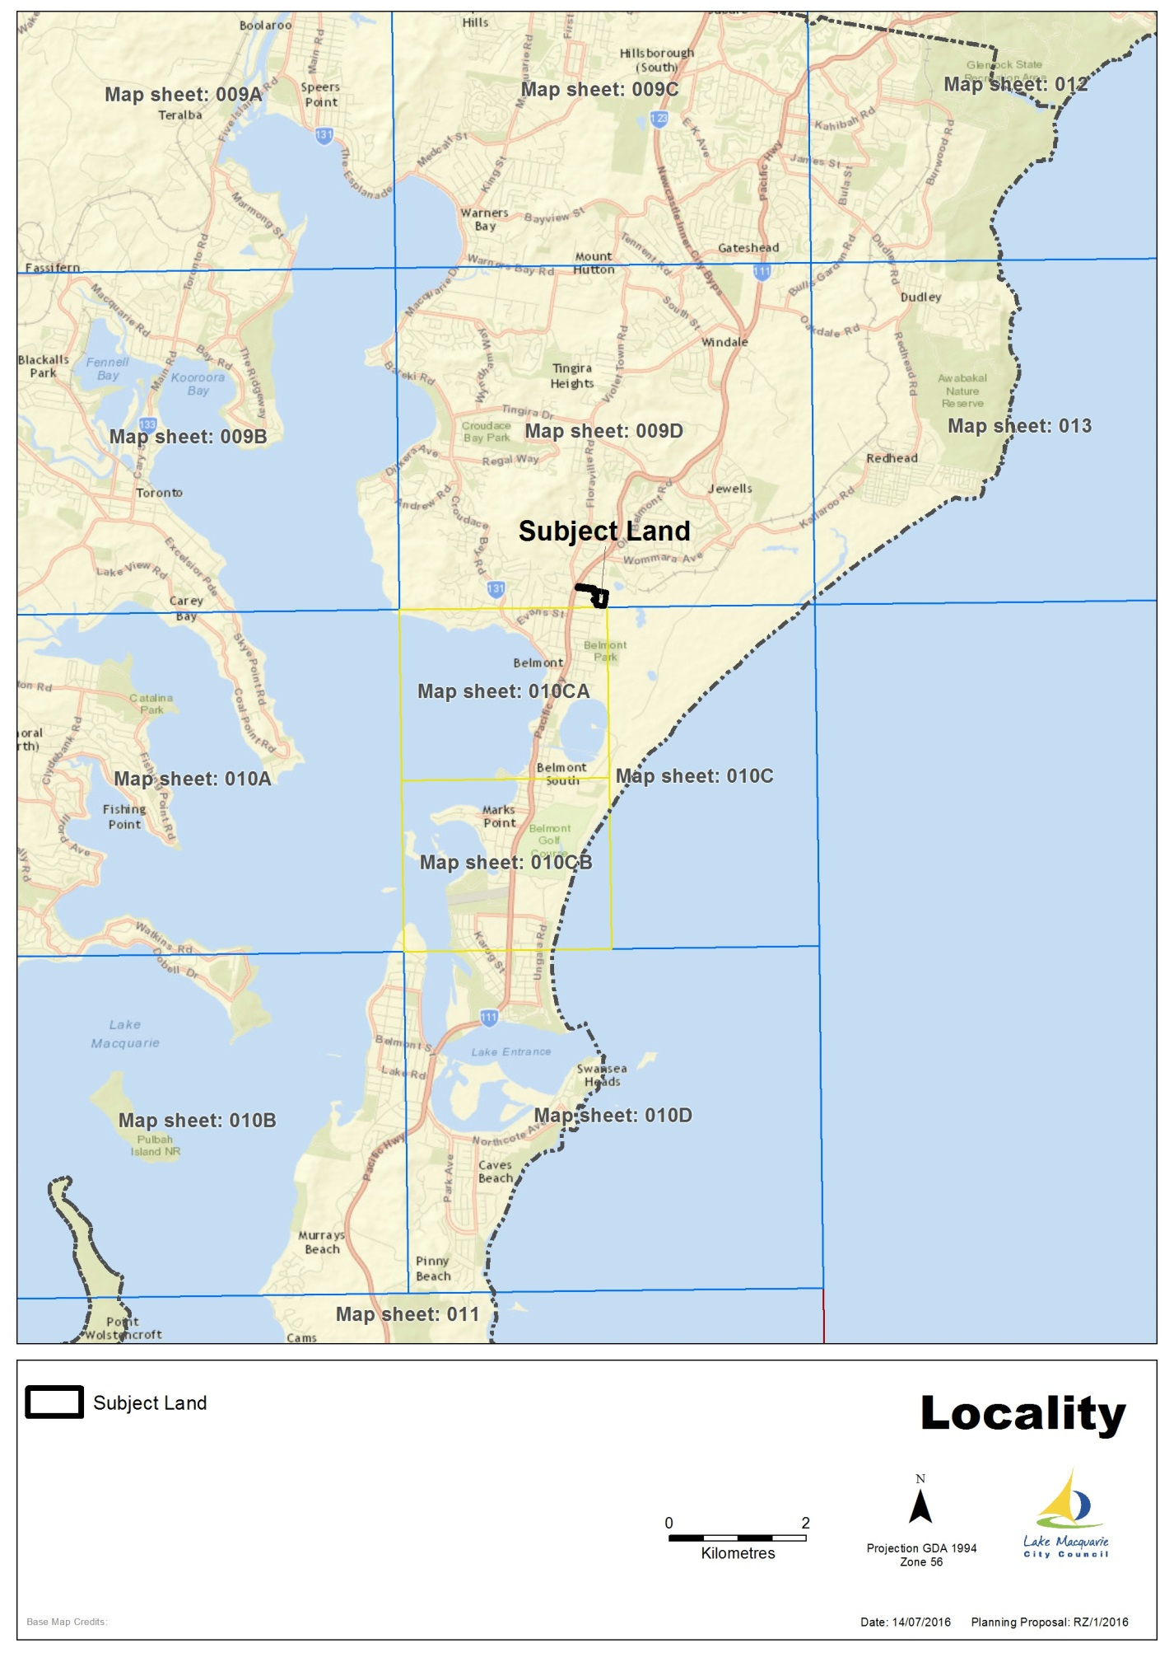

**Map 1 – Locality**

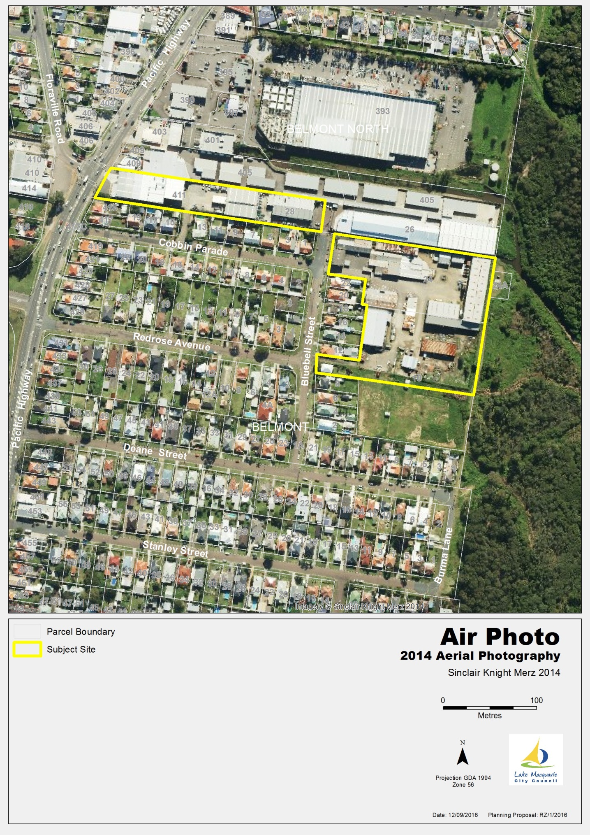

**Map 2 – Aerial Photo**

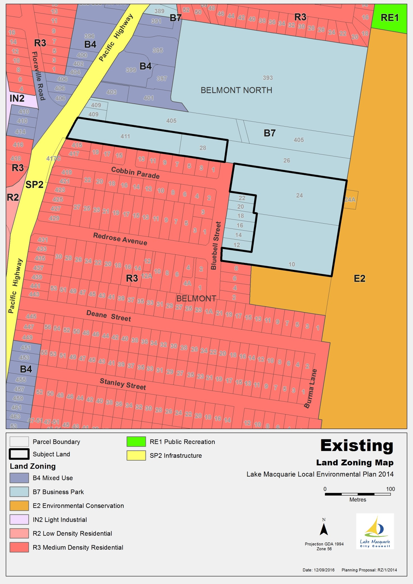**Map 3 – Proposed Zone under LMLEP 2014**

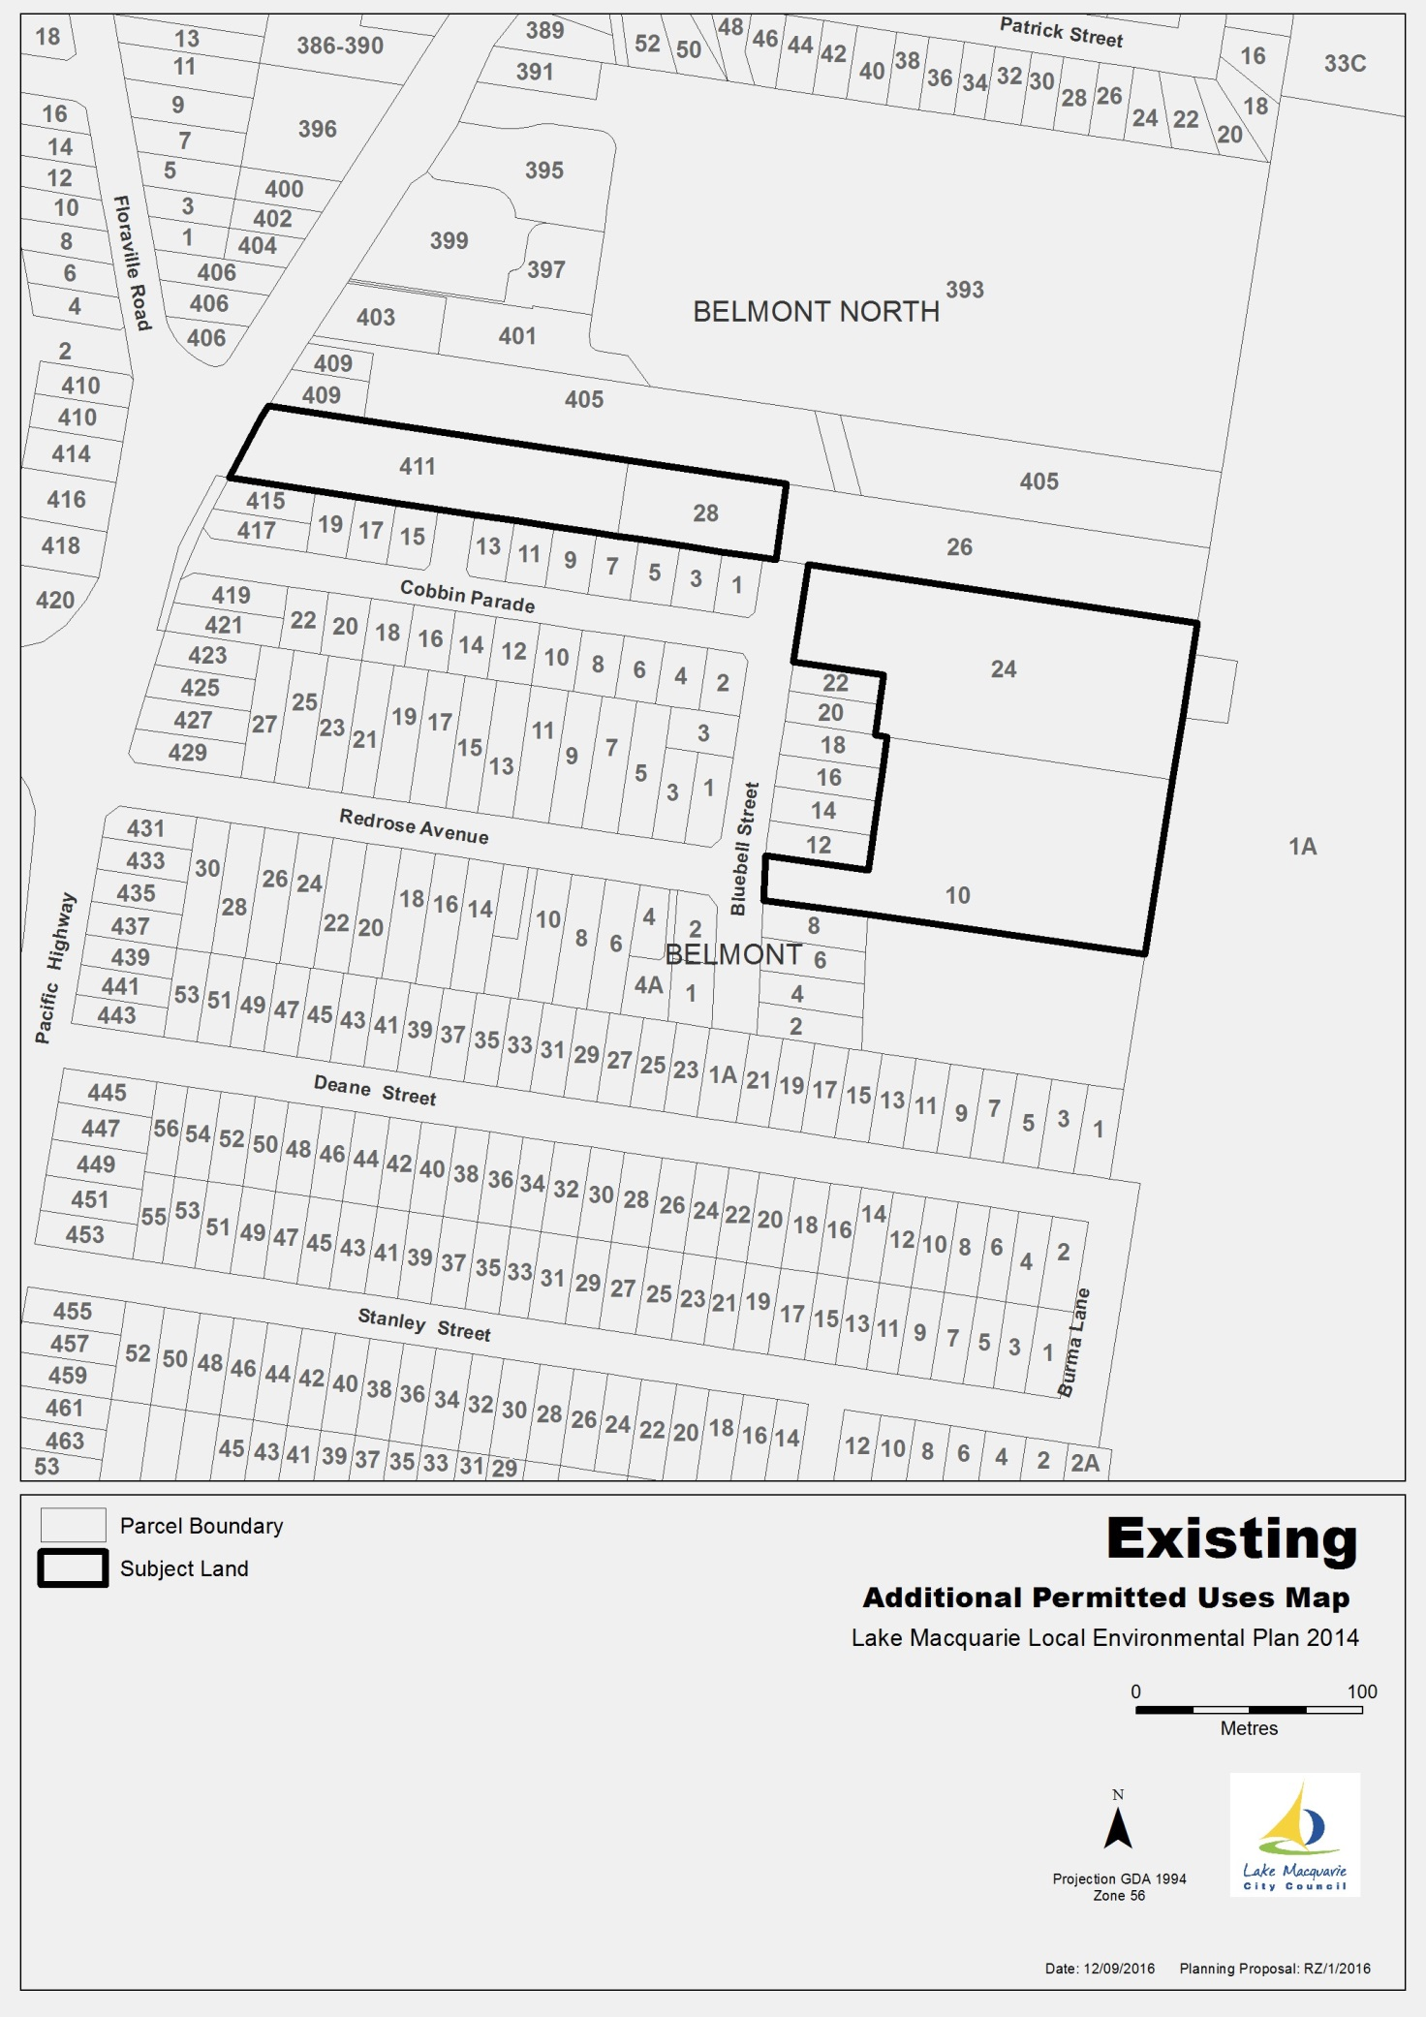**Map 4 – Existing Uses**

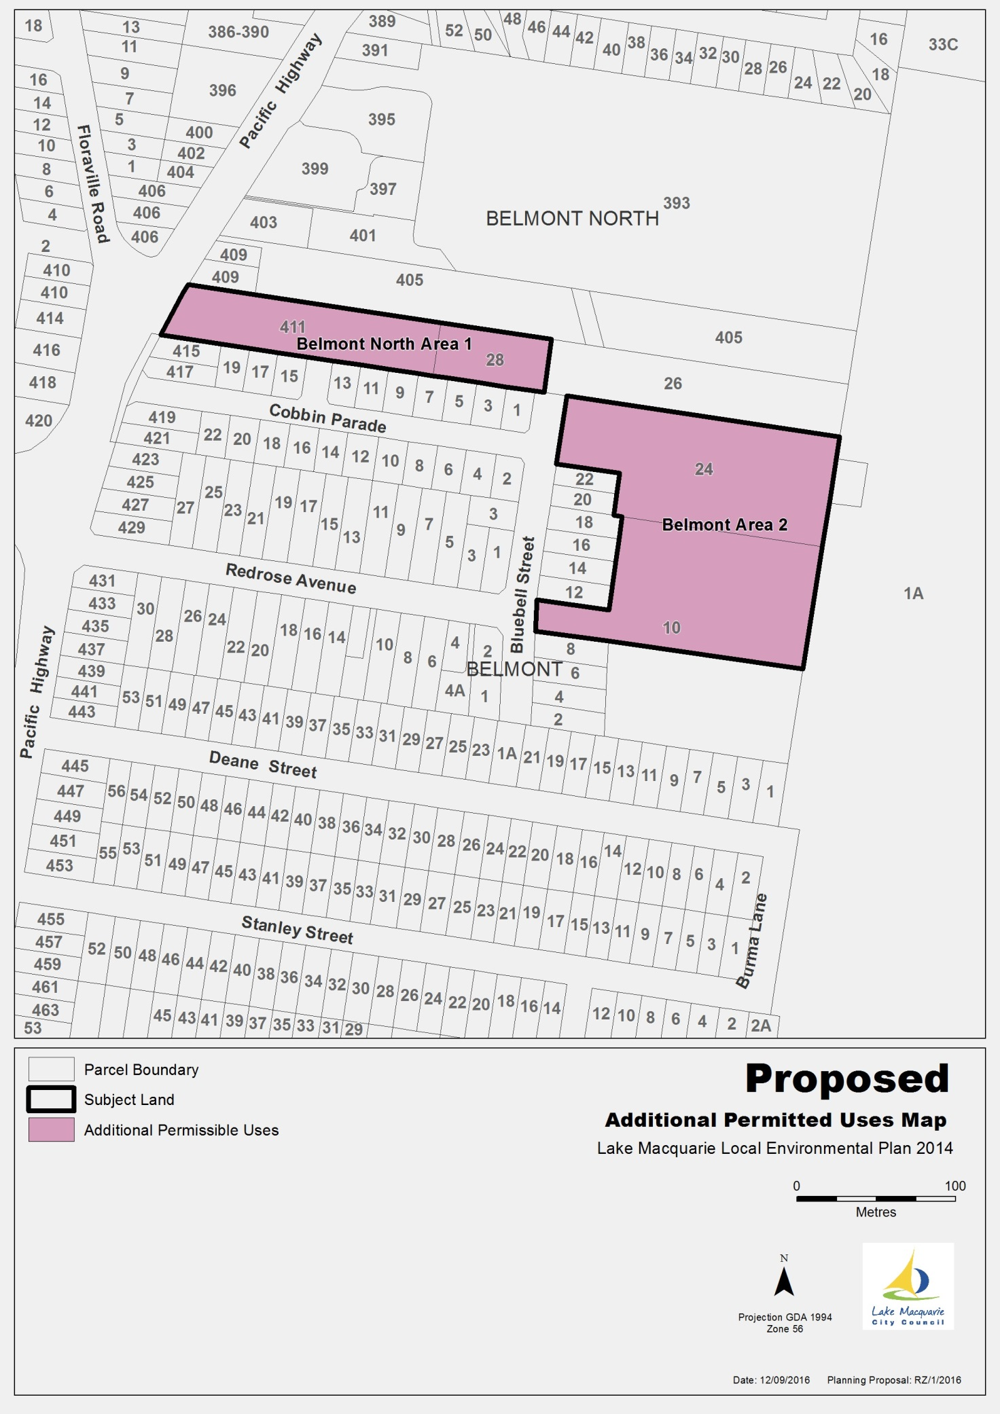 **Map 5 – Proposed Additional Permitted Uses**

**Part 5 – COMMUNITY CONSULTATION**

It is recommended that the Planning Proposal be publicly exhibited for a period of at least 28 days after the determination of Council.

**Part 6 – PROJECT TIMELINE**

|  |  |
| --- | --- |
| **Action** | **Timeframe** |
| Anticipated commencement date (date of Gateway determination) |  |
| Anticipated timeframe for completion of required technical information |  |
| Timeframe for government agency consultation (pre exhibition) |  |
| Public exhibition (commencement and completion dates) |  |
| Date of Public hearing (if required) |  |
| Consideration of submissions |  |
| Timeframe for government agency consultation (post exhibition if required) |  |
| Post exhibition planning proposal consideration / preparation |  |
| Submission to Department to finalise LEP |  |
| Date RPA will make Plan (if delegated) |  |
| Date RPA will forward to the Department for notification (if not delegated) |  |